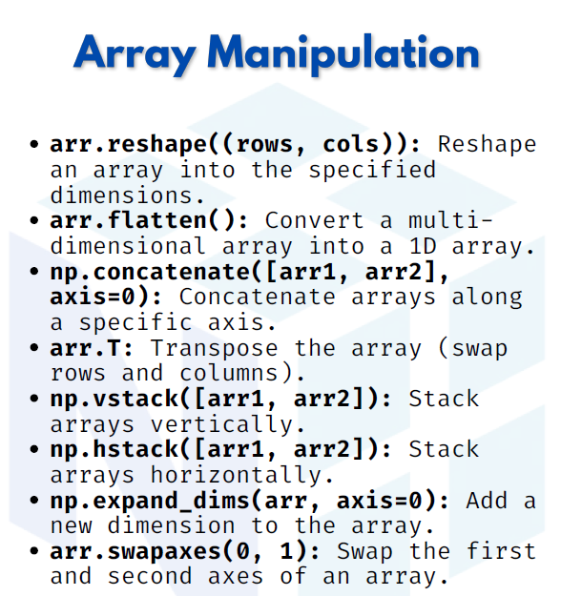

NUMPY ARRAY MANIPULATION

1. arr.reshape((rows, cols)) → Reshape an array into given dimensions
The reshape() function changes the shape of an array without changing its data.
Useful when converting a 1D array into 2D, 3D, etc.

import numpy as np
arr = np.arange(6) # [0 1 2 3 4 5]
reshaped = arr.reshape((2, 3))
print(reshaped)
Output:
[[0 1 2]
[3 4 5]]

2. arr.flatten() → Convert multi-dimensional array into 1D
The flatten() function reduces any N-dimensional array into a single dimension.
arr = np.array([[1, 2], [3, 4]])
flat = arr.flatten()
print(flat)
Output:
[1 2 3 4]
3. np.concatenate([arr1, arr2], axis=0) → Join arrays along axis
The concatenate() function joins multiple arrays into one.
- axis=0 → row-wise (vertical)
- axis=1 → column-wise (horizontal)
arr1 = np.array([[1, 2], [3, 4]])
arr2 = np.array([[5, 6]])
merged = np.concatenate([arr1, arr2], axis=0)
print(merged)
Output:
[[1 2]
[3 4]
[5 6]]

4. arr.T → Transpose of an array (swap rows & cols)
The .T attribute flips an array over its diagonal, converting rows → columns and vice versa.
arr = np.array([[1, 2, 3], [4, 5, 6]])
print(arr.T)
Output:
[[1 4]
[2 5]
[3 6]]

5. np.vstack([arr1, arr2]) → Stack arrays vertically
The vstack() function stacks arrays on top of each other (row-wise).
arr1 = np.array([1, 2, 3])
arr2 = np.array([4, 5, 6])
stacked = np.vstack([arr1, arr2])
print(stacked)
Output:
[[1 2 3]
[4 5 6]]

6. np.hstack([arr1, arr2]) → Stack arrays horizontally
The hstack() function stacks arrays side by side (column-wise).
arr1 = np.array([1, 2, 3])
arr2 = np.array([4, 5, 6])
stacked = np.hstack([arr1, arr2])
print(stacked)

Output:
[1 2 3 4 5 6]

7. np.expand_dims(arr, axis=0) → Add a new dimension
The expand_dims() function increases array dimensions by adding a new axis.
Helpful in machine learning (when handling batches of data).
arr = np.array([1, 2, 3])
expanded = np.expand_dims(arr, axis=0)
print(expanded)
Output:
[[1 2 3]]

8. arr.swapaxes(0, 1) → Swap given axes of array
The swapaxes() function swaps two specified axes of an array.
It’s useful when working with multidimensional data.
arr = np.array([[1, 2, 3], [4, 5, 6]])
swapped = arr.swapaxes(0, 1)
print(swapped)
Output:
[[1 4]
[2 5]
[3 6]]

